Workbook: Healing Haunted Histories Course:Doing the work of Settler-Indigenous Reconciliation
October 2023

Introduction: Prepping for the Course.
Welcome. If you are starting this workbook, then it is more than likely that you have committed to this 5 week process of the Healing Haunted Histories course. We are confident that the next weeks will be very meaningful and undoubtedly challenging for you.

To get the most out of our time together each Sunday morning (Don’t forget we want to begin promptly at 9am so make sure you arrive well before that) we are providing this workbook and weekly podcasts to share important content and have you do some of your own prep work. None of this work is compulsory, but the more work you do on your own will enhance the learning and meaning in the course.

It should be said that the purpose of the course is not just to learn stuff about indigenous/settler reconciliation, but to help all of us grow in our capacity to be response-able as individuals and as a community.

Things you will need for each week.
- Access to the Book - Healing Haunted Histories by Elaine Enns and Ched Myers.

- The Workbook - Either in printed form or on a digital device.

- The Podcast - take 30 minutes to listen to it before each session so you are prepared for small group conversation and sharing.

- An open mind and heart, a willingness to connect to your own story, the story of others and the movements of God’s story and dream for reconciliation, and a hope to be a responsive partner in the task of healing harms and moving towards a more just world.

The Aims of the Course
This course has similar aims as the book Healing Haunted Histories p.10 (referred from now on as HHH) which is to encourage, challenge, and capacitate settler Christians) to:

- understand how our histories, landscapes, and communities are haunted by the long and continuing history of Indigenous dispossession wrought by settler colonialism;

- transform the self-understandings, lifeways, and structures we inhabit;

- and •practice restorative solidarity with Indigenous communities as part of a wider movement of decolonization.

Definitions

In this articulation of the course aims, you may have noticed a number of terms (mostly bolded) that may be new to you. So we want to start with defining a number of important terms for this type of work. These definitions come directly from HHH, p.11-13.

Since these explanations can sound quite academic and long, we have included a TL;DR (which is internet speak for Too Long: Didn’t Read) to simply and concisely give you some understanding. The complete definition will give you more nuance and depth.

Settler: TL;DR - People who have settled in a place and have been a part of or complicit in the sidelining of Indigenous peoples and cultures.

In this book we use this term to refer primarily to people of European descent whose ancestors immigrated to and established themselves in North America (this includes both of us authors). More prevalent in Canada than the U.S., the rubric of “settler” acknowledges (rather than ignores) the violent and conflicted legacy of settler colonialism in North America since the sixteenth century. Settlers “come to stay,” says Patrick Wolfe succinctly, on an “expropriated land base.”11 And settler descendants keep “resettling” as we move around the country (see below 5D). We appreciate Eve Tuck and Wayne Yang’s assertion that “Settlers are not immigrants. Immigrants are beholden to the Indigenous laws and epistemologies of the lands they migrate to. Settlers become the law, supplanting Indigenous laws and epistemologies.”12 While we acknowledge the politics of their distinction, we will here use the word immigrant for people who came from the “old” country to the “new,” and “settler” for their identity once here. Second, while the term settler includes non-European immigrants of color, we are aware that these often exploited and marginalized communities face distinct issues. This differentiation is even more acute among those in the African diaspora who are descendants of enslaved peoples (sometimes referred to as “stolen people on stolen land”). We point the reader to the important growing literature arising from these communities.13

Haunting: TL;DR - The idea that historical realities known or unknown play a role in our present lived realities.

“Hauntology” (a “portmanteau of haunting and ontology”) was coined by French philosopher Jacques Derrida to recognize how both identity and history are populated by “ghosts . . . which are neither present nor absent.”14 The concept was picked up and developed by sociologist Avery Gordon to describe ways in which the “spirit” of past violence inhabits both places and people, a framing that has animated a growing body of decolonial-critical literature.15 We find “haunting” to be an illuminating trope for those of us trying to come to terms with the personal (psychosis), communal (possession), and political (occupation) dimensions of colonization.

Settler colonialism: TL;DR - In contrast to Classical Colonialism where a conquering empire, uses a place to oppress the locals and exploit the resources of a country (eg. African countries like Belgian Congo, French Algeria), Settler Colonialism’s objective is to acquire land so that colonists can settle permanently and form new communities. (eg. Canada, US, South Africa)

This term has “become the ‘official’ idiolect with substantial influence in the social sciences and the humanities,” but has varying and contested definitions.16 A useful one is: “a distinct type of colonialism that functions through the replacement of indigenous populations with an invasive settler society that, over time, develops a distinctive identity and sovereignty. Settler colonial states include Canada, the United States, Australia, and South Africa.”17 Wolfe adds that settler colonialism’s “logic of elimination” toward Indigenous peoples includes “miscegenation, the breaking-down of native title into alienable individual freeholds and citizenship, child abduction, religious conversion, resocialization in total institutions such as missions or boarding schools, and . . . frontier homicide.”

Restorative solidarity: TL;DR - The process of settlers working to understand and heal the impacts of settler colonialism in our time and place. In other words “making things right”.

This term joins the framework of restorative justice (which we explored in our 2009 Ambassadors of Reconciliation volumes) together with the traditional definition of solidarity as “shared interests” across differences and work toward mutual liberation. For those of us who historically have been and continue to be advantaged in and by the settler colonial system, both restorative justice and solidarity are about “making things right.” Nikki Sanchez puts it plainly to settlers: “This history is not your fault, but it is absolutely your responsibility.”19 This book is about the latter, not the former. We understand settler restorative solidarity as the practice of “response-ability” in both our “political bodies” and the “body politic” in which we dwell. This entails working to dismantle and heal from settler colonialism, as well as to accompany and collaborate with Indigenous communities, especially those on (or of) lands on which we’ve settled. (See image below)

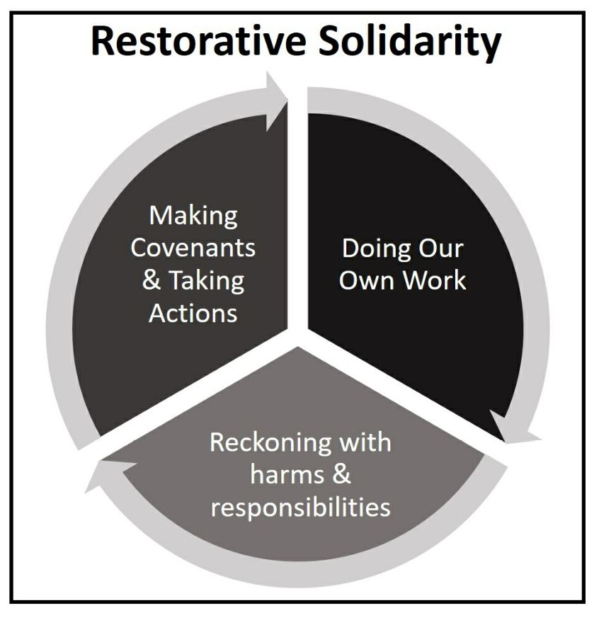

Decolonization: TL;DR - Most simply when a colonized country regains its independent status, but more recently it has meant more the process of understanding and freeing our thinking from the reality of colonialism.

With its popularization over the last decade, this term has become diluted in non-Indigenous discourses. We agree with Tuck and Yang that its core meaning should connote the struggle for “the repatriation of Indigenous land and life,” and not function as “a metaphor for other things we want to do to improve our societies”: Decolonize (a verb) and decolonization (a noun) cannot easily be grafted onto pre-existing discourses/frameworks, even if they are critical, even if they are anti-racist, even if they are justice frameworks . . . The goal is to break . . . the settler colonial triad [which] means repatriating land to sovereign Native tribes and nations, abolition of slavery in its contemporary forms, and the dismantling of the imperial metropole.21

Session 1 - October 15

Things to do before coming to the first session.

- Listen to the Session 1 Podcast - All course material can be found at www.seedschurch.ca in the Pinned Post - Healing Haunted Histories Course Central.

- Recommended reading. Most important? HHH, p.3-31 If you have time HHH, p.57-79

- Take a few minutes to reflect on these questions? (We will spend a big part of the first session sharing about these questions.)

  - What brings you to this course/conversation?

  - What are your questions, fears, and hopes?

  - What is your “red dot”? Where are you at in this conversation? Feelings, thoughts, wonderings.

- Identify a family line or person that you wish to explore. Bring a picture or symbol of your ancestor.

For people of Mennonite Heritage a helpful online tool for tracing your family line is GRANDMA Online.

Go to grandmaonline.org Username: seedschurch Password: makejesusreal

Try the QuickSearch link. It’s usually helpful to put in a margin of 3 to 5 years on the birth date. A number of names will come up and find the one related to you. Now you can use your entry to trace back to parents, grandparents, etc.

- Why did you choose this particular person or ancestral line?

Session 2 - October 22

Things to do before coming to the second session.

- Listen to the Session 2 Podcast - This podcast will give you much needed background for working the questions below in relation to your identified ancestor. All course material can be found at www.seedschurch.ca in the Pinned Post - Healing Haunted Histories Course Central.

- Recommended reading. Chapter 2 - Landlines I, Chapter 3 - Bloodlines I and Chapter 4 - Songlines I. *** NOTE: This is a lot of reading, so it isn’t mandatory to read it all, but take some time to skim through the chapters and major headings. The most important stuff will be addressed in the questions below. ***
- Landlines, Bloodlines, Songlines Exploration

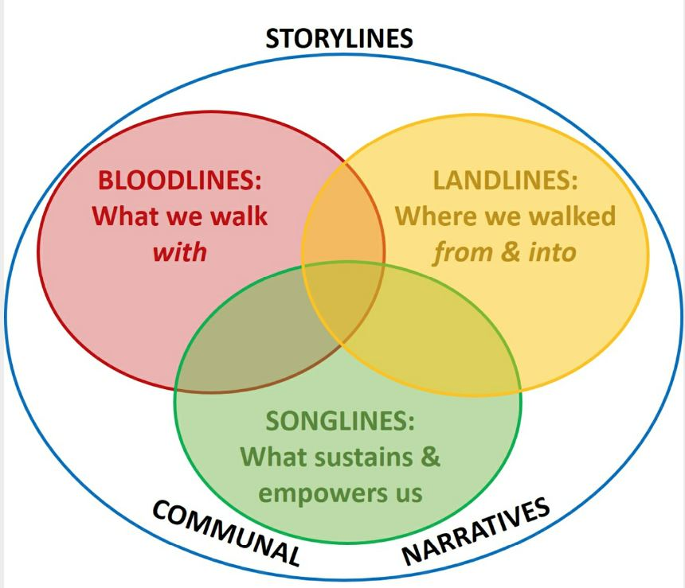

- Landlines

Landlines is the work of understanding our immigrant ancestors’ journeys from country of origin to Turtle Island. Which country or continent did your ancestor come from, and approximately when?

What were push and pull factors of their migration (p.67-68 HHH)? Were they Colonists, Opportunists, Distressed Immigrants, Forced Relocators?

How many times have you moved geographies from where you were born?

What is the name of the Indigenous territory and watershed in which you reside now?

Important questions or queries to help you think through your ancestors history. (p.77-78, HHH)

- What kind of land(s) or cities did your immigrant ancestors leave? Invite interviewees to describe in as much detail as they can those homeplaces, including topology, ecology, and built environments in which they (or their ancestors) dwelled. Did they exhibit similar geographic characteristics to the place(s) to which they immigrated? (If you ever make a pilgrimage to the place your ancestors came from, see if you “recognize” the land.)

- How many generations had lived in that original homeplace? What earlier migrations had brought them there? How and why?

- What were the primary tongues your immigrant ancestors spoke in their country of origin?
- What was the class stratum of your ancestors: poor/peasant; working-class; middle-class; landed gentry; other?

- Was their immigration voluntary, involuntary, or forced? What were the larger push (e.g., war, famine, landlessness, or unemployment) and pull factors (e.g., family reunification, economic opportunity, religious freedom) that impelled migration?

- What political forces of boom or bust, poverty or affluence, discrimination or social violence, shaped their movements during that historical period?

- Were your ancestors advantaged or marginalized during their immigrant journey (did they travel as stowaways or in suites? was the journey merely long or was it dangerous?)? Did they come as a large family or community, or individually?

- Did they have immigration (or legal) documents? Were they promised land or work when they got to their new country?

- If they incurred travel debt, how was it paid off?

- Who did your immigrant ancestors leave behind, and what property, homes, and livelihoods? Why did other family or community members stay? Did they remain connected?

- Bloodlines

Bloodlines “explores questions of what we have inherited, biologically and psychically, and how we carry it. We do not use “Bloodlines” narrowly as genealogical lineage only, but broadly to include particularities of family and group socialization: our embodied story.148 It includes what we are born into (place; racial, ethnic, and gender formation; social status; cultural traditions); how we were taught to be a part of a family and community; the stories we were told (and retell) about who our people were and are; and legacies we have inherited, both painful and proud.” (p.87, HHH)

Why did you choose to focus on this ancestor?

What do you know about them, and how do you know it?

Do you see any impacts in your family or communal system from moral injury or intergenerational trauma?

“Bloodlines work can sometimes feel like doing surgery on living flesh. Exploring your family and community traditions requires care. But ultimately, bearing family and community memory, especially regarding trauma, means trying to make sense of these traditions, not simply passing them on uncritically or timidly as mere artifacts or curios. A discipleship of decolonization invites us to “reread” our peoples’ stories mindfully, and to revise them compassionately, through our commitment to healing and restorative solidarity.” (p.108-109)

Important queries or questions about your ancestor’s bloodlines (p.108, HHH)

- What stories are told easily and often, and with what affect in both storyteller and listener? Are there aspects of stories that are not included in particular tellings or by certain people or sources?

- What stories have been silenced, dismissed, denied, or covered up in your ancestral narratives, and what feelings does that stir in you?

- How are women and sexual minorities portrayed? Does gendered violence or discrimination get addressed? Are such stories suppressed in your communal narrative (accounts of both pain and loss, and of courage and cunning)?

- Who tends to be portrayed as heroes or villains in communal tales, and how?

- Are there any fictional or academic historical accounts of your larger community’s story?

- Do you see footprints of intergenerational trauma or unresolved historic pain in your family or community (e.g., early death, depression, anxiety)? How does it get articulated or manifested?

- What are ways your people may have been complicit in—or challenged—events or systems that traumatized others (e.g., displacement of Indigenous peoples, the slave trade, class oppression)? How are such matters processed or erased in your family story?

- How do you carry intergenerational pain, loss, shame, or pride?

- Songlines

“Songlines are the narratives, cultural practices, and ceremonies that sustain and transform individuals and communities. They are stories of conviction we seek to live by, and which motivate us in the work of justice and decolonization, consoling our suffering and inspiring us to end the suffering of others. Songlines inspire and empower us to resist and transform situations of oppression, guide us in healing past and present wounds, and remind us how to be human. These traditions are many and diversely expressed, and every community has them. In this book we focus mainly on two strands: those articulated through religious faith, and through the testimonies of social movements for humanization—and especially the intersection of the two.” (p. 113-114, HHH)

What tradition(s) of faith and resilience did your ancestor lean on?

What Songlines animate your work for justice now (HHH, Ch. 7)?

- Which Songlines did you learn in your family, and at what age(s)?

- Which ones are from life in your ancestors’ country of origin, and which from the immigrant experience?

- What faith tradition(s) did your ancestors practice, and what spiritual impacts did immigration have?

- What spaces of your community (workplace, church, school, or dancehall) stewarded Songlines traditions, and in what forms?

- Which Songlines are in danger of being lost, and why? What might you do to help preserve and strengthen such traditions?

- What family stories narrate courage, compassion, and conscience? Do they evoke heroism or humility? Is there adequate social and historical context associated with the telling, or have they morphed into individualistic or moralistic tales?

- Are you able to tease out troubling aspects of settler denial or dysfunction that might be woven into otherwise liberating Songlines? How might these stories be critically revised?

- What are examples of resilience in your community? Of solidarity with other peoples, especially those who were marginalized?

- What ethnic expressions have been retained in the transmission of Songlines?

- How did/do ancestral Songlines stand in tension with race/class/gender socialization or expectations, then and now?

- What exemplary individuals or social movements were inspirational to your ancestors and family?

- Where are hidden stories of grassroots goodness and neighborliness?

- Are there Songlines you would like to strengthen or even recontextualize for your life today?

Session 3 - October 29

Things to do before coming to the Session Three.

- Listen to the Session 3 Podcast - This podcast will give you much needed background for working the questions below in relation to your identified ancestor. All course material can be found at www.seedschurch.ca in the Pinned Post - Healing Haunted Histories Course Central.

- Recommended reading. Chapter 6 - Bloodlines II pp. 199-235. Please read as much of this as possible. If you are short of time focus on pp. 213-223

- Questions for reflection

“In contrast to colonial traditions of retributive justice and settler dodges of innocence, restorative justice seeks the personal and community healing of both victims and perpetrators of injustice. But for settlers, this requires an ongoing journey of repentance/recovery/complicity, the keystone practice of de-assimilation from settler colonialism. As you consider the questions below, remember that if you cannot find the specifics of your ancestors’ entanglements in settler colonialism (after persistent digging), then your Bloodlines work should focus on your own social story and landscape.” (HHH,p.234)

- What are some of the privileges (or disadvantages) your ancestors/you accrued during settlement?

- How was your family story lost, overwritten, or silenced by internal or external forces? How was it distorted by dominant cultural myth?

- What is missing from your family/communal stories of settlement? What is intentionally passed over, and why? How does it feel to carry unknown pieces of your family history? How has this affected your identity?

- When and how did you/your family “become white?” Do you retain any ethnic traditions (i.e., language, food, customs, music, trades)? What cultural losses do you feel existentially? If you don’t really care, why not?

- How might your immigrant ancestors have been complicit in events or systems that traumatized others?

- What “moves to innocence” do you most employ? How can you interrupt these practices and work towards solidarity?

- Which framework of “turning” most resonates with you: the theological rhetoric of repentance, the recovery language of Twelve-Steps or the juridical metaphor of complicity? Or do you draw from each, and if so, how?

- How do you think you and/or your ancestors may suffer from moral injury as a result of entanglement with settler colonialism? Think not only of acts of “commission,” but also losses due to “omission.”

- What are differences between the work of addressing the complicity of your ancestors, and that of your own where you now live? How can tackling one encourage work on the other?

- What are concrete strategies of de-assimilation you’ve been pursuing? How might you deepen them?

Session 4 - November 5 Healing Hauntings

Things to do before coming to the Session Four

- Listen to the Session 4 Podcast - A conversation with Elaine Enns and Ched Meyers of Bartimaeus Cooperative Ministries website. This podcast will give you much needed background for working the questions below in relation to your identified ancestor. All course material can be found at www.seedschurch.ca in the Pinned Post - Healing Haunted Histories Course Central.

- Recommended reading. Chapter 8 - Healing Hauntings: A Discipleship of Decolonization. P. 273-309 Please read as much of this as possible. If you are short of time focus on p. 273-282.

Session 5 - November 12 Moving to the Next Step for OUR healing - What does it mean for us to be a covenantal community on Treaty One land?

Special Guest - Elder David Scott, Swan Lake First Nation

- Listen to the Session 5 Podcast.

- Recommended reading. Theological Interludes - p. 131 to 151, HHH

